Microcal Software Update Instructions
- Start the MicroCal by pressing the power switch on the left side of the unit (see Figure 1). The software will start up on the Real Time screen (see Figure 2).

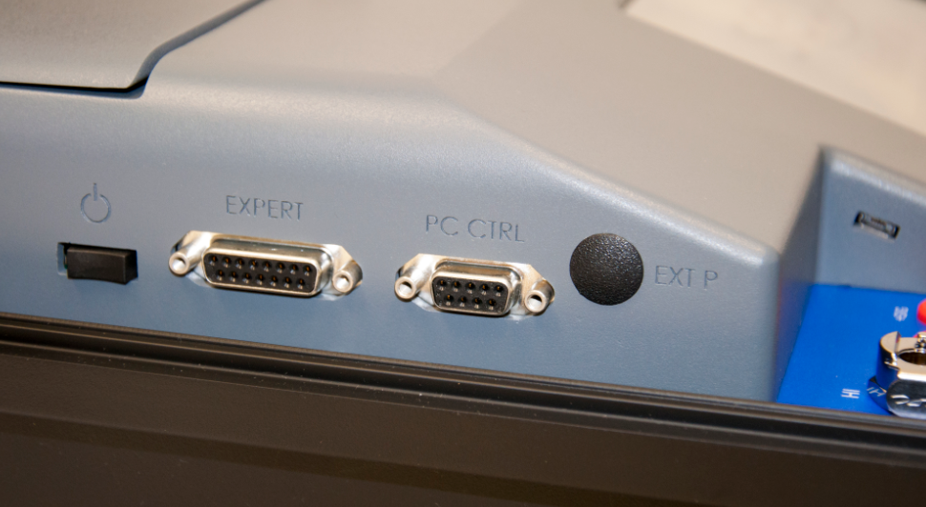
Figure 1: MicroCal Power Switch

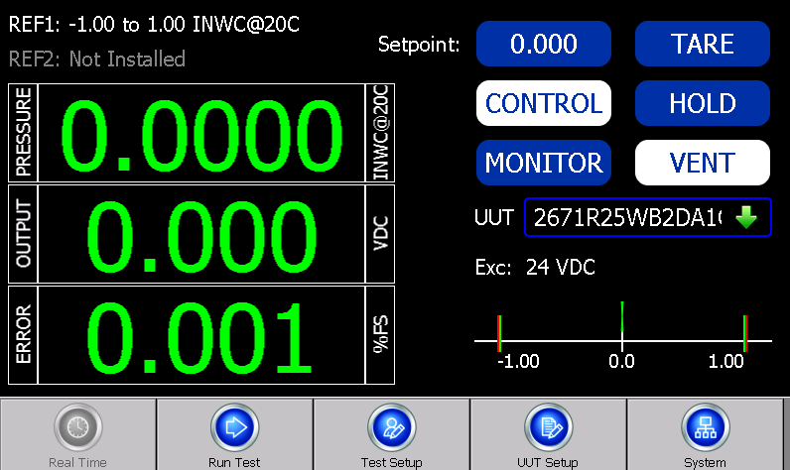
Figure 2: Real Time Screen

- From the “Real Time” screen, click the system button in the bottom toolbar. The Microcal user interface software must be shut down prior to installing newest software. To shut down the software, click the “X” in the upper right-hand corner on the “System” tab of the Microcal (see Figure 3).
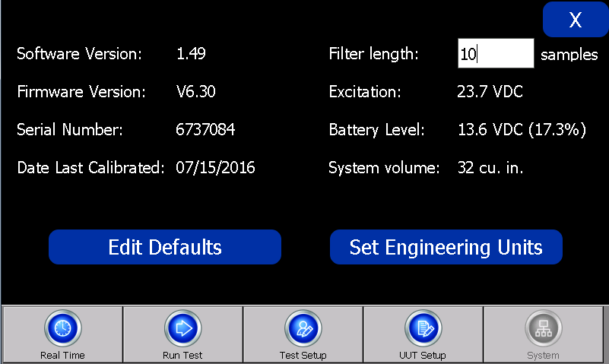
Figure 3: System Tab
- This will bring up a screen displaying “Setra Microcal Advanced Modular Pressure Calibrator” (see Figure 4). Once this screen is displayed, the software is no longer running and may be updated.
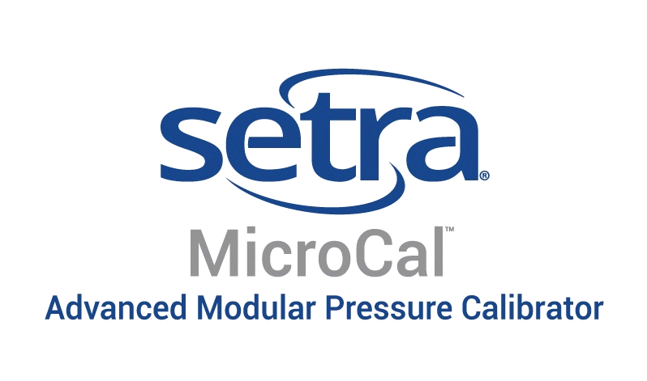
Figure 4: This screen ensures that the Microcal software is no longer running

- Download the latest software from the Microcal Product page (see Figure 5) and save in an easy to access location: MicroCal Product Page Link

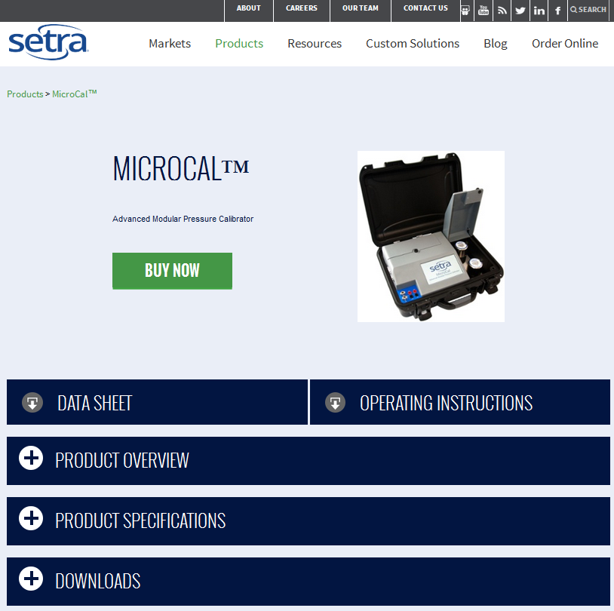
Figure 5: MicroCal Product Page

- Plug the micro USB cable into the port of the Microcal and the other end into an available USB port on a computer (see Figure 6).

Figure 6: Micro USB Port On MicroCal

- The software “Windows Mobile Device Center” should begin downloading (First time install may take up to 5-7 minutes). Once the software is downloaded onto your PC and is running click on “Connect without setting up your device” (see Figure 7).
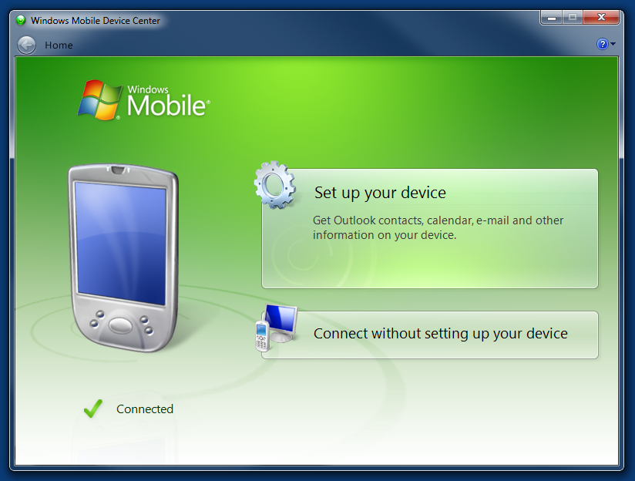
Figure 7: Windows Mobile Device Center main menu screen
- Click on “File Management” and then “Browse the contents of your device” (see Figure 8).
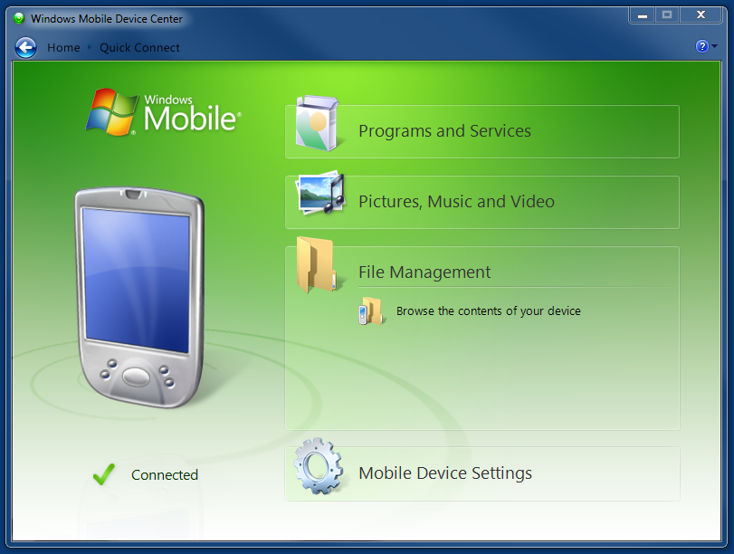
Figure 8: File Management Screen
- Double-click on “Mounted Volume” (see Figure 9).
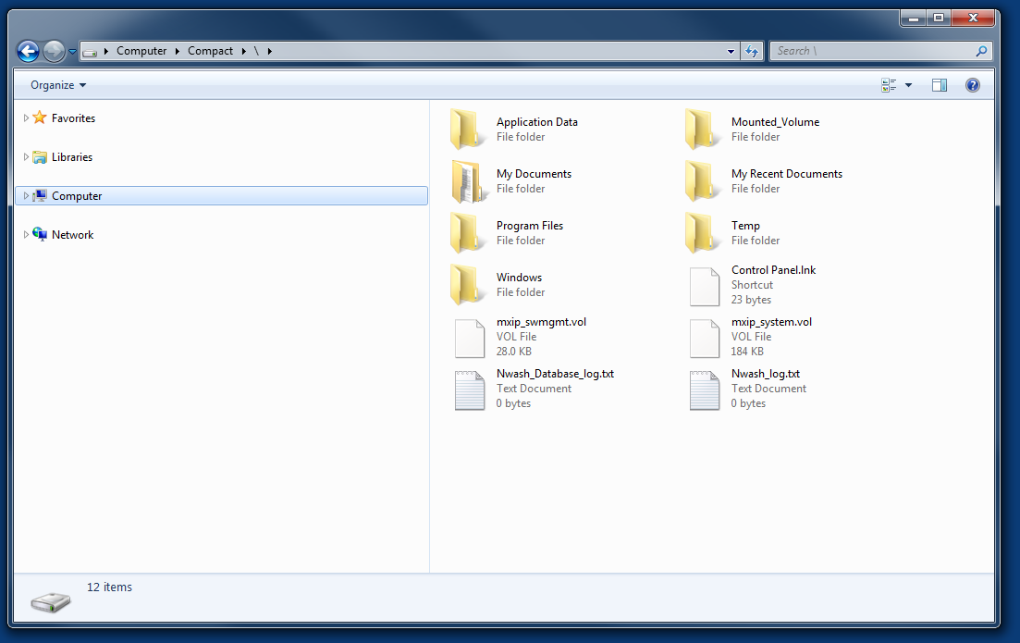
Figure 9: Mounted Volume Folder
- Double-click on the mounted volume drive shown below (see Figure 10).
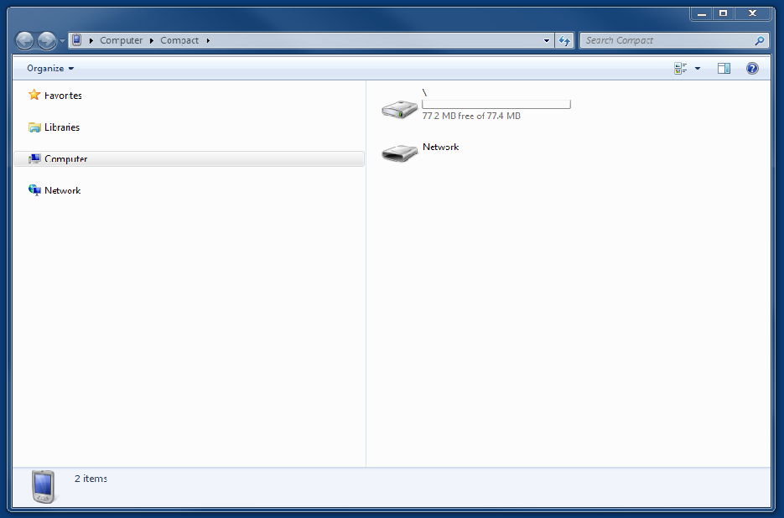
Figure 10: Mounted Volume Drive

- In this location, copy “MCAL.exe” file from step 4. This will replace the existing .exe file with the same name. A pop up message (see Figure 11) will appear asking if the file being copied should replace the existing file, click “Yes”. The software will start to update, once this step is complete the software is updated.

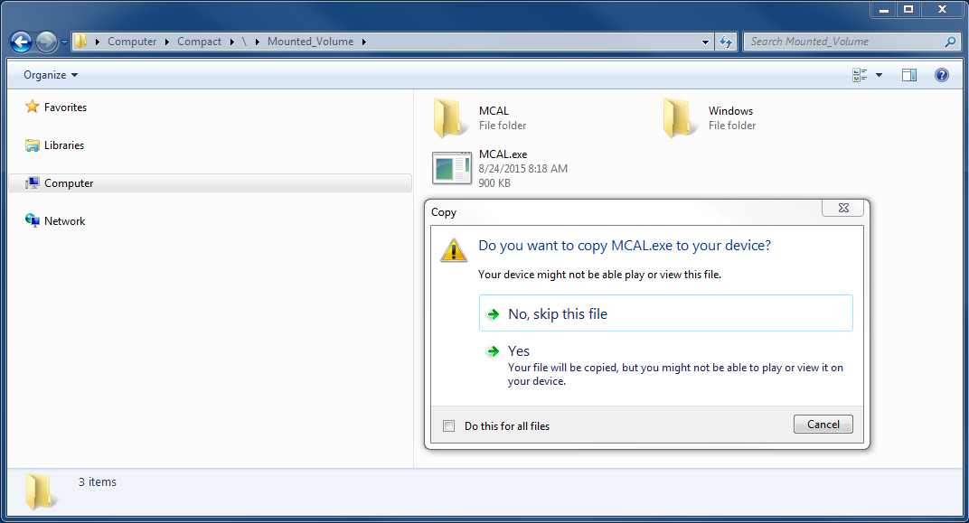
Figure 11: Over-write Pop Up Message
- Cycle the power on the Microcal and the new software will be updated and running on the unit. Normal use of the MicroCal can now begin.
SS-MCAL SOFTWARE UPDATE REV. A

